Download, update to and install Office 365
Important Information: This is not available to download from the School or Corporate networks, it must be done from home.
- Open internet browser and navigate to http://office.com
- In the top right corner click on "Sign in"
- In the Username field, type in your EQ (e.g. jsmith1@eq.edu.au) or QED (e.g. joe.smith@qed.qld.gov.au) email address and click "next".
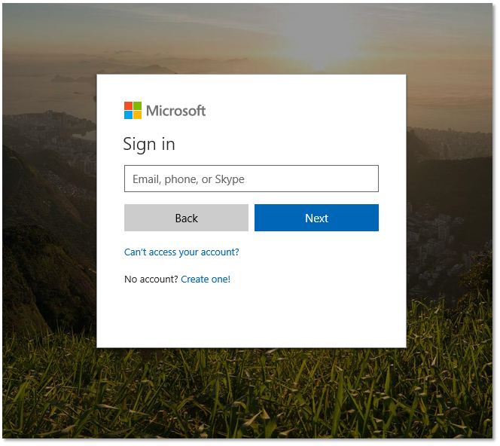
- You will be prompted for your username and password on the online authentication page. Type your username and password.
- Click Login
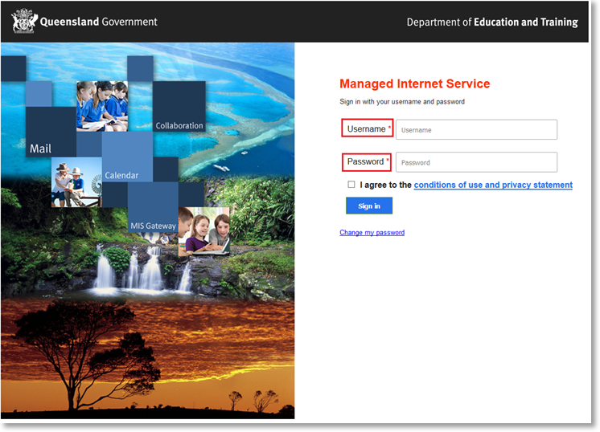
- In the top right corner, click on the "Install office apps" then "Office O365".
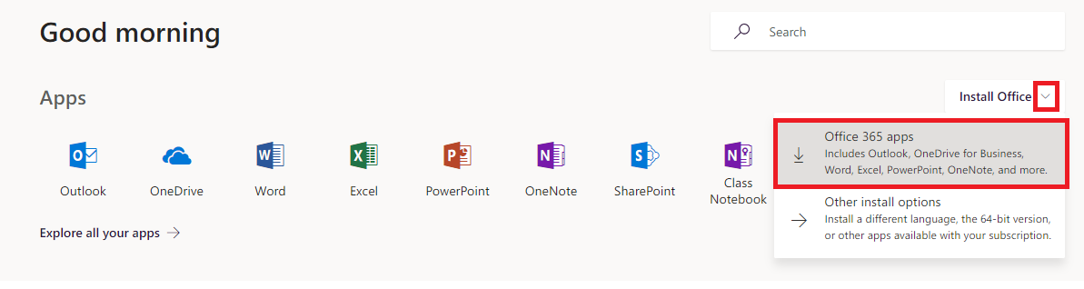
7. A pop up message will appear prompting you to run or save the .exe file. Ensure that the source is as per below - c2rsetup.officeapps.live.com.
8. Click on ‘Save’. The file will automatically begin to download.
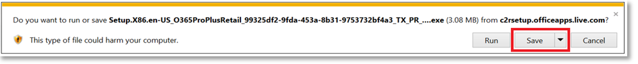
9. When the file has completed downloading, click on ‘Run’.
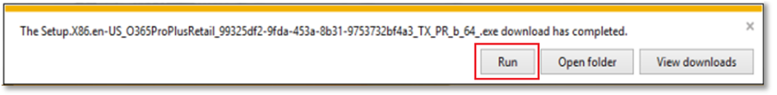
Please note this file is approx. 2gb and may take a while to download depending on your bandwidth speed.

10. You will be prompted with a message to make changes to your computer. Select ‘Yes’.
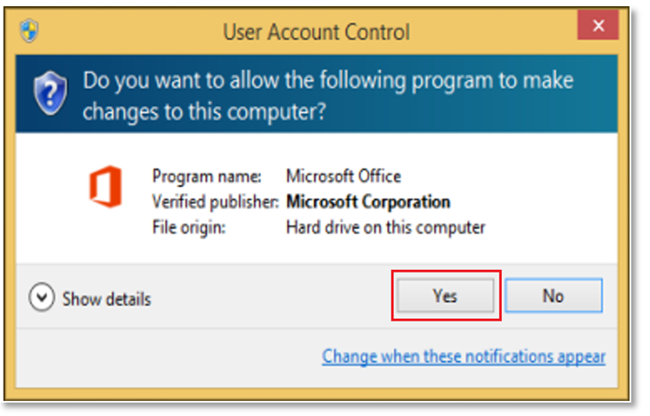
11. Office will start downloading.

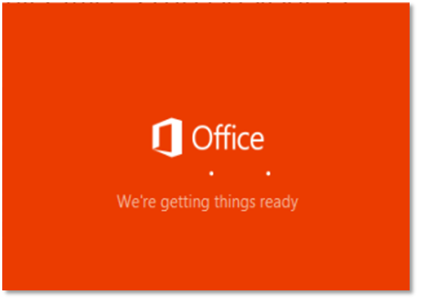
You will also see the office icon pop up on the task bar.

12. Office 365 will start to install onto your computer, wait for this to finish.
Note: If you currently have Office 2013 installed, ensure all Microsoft applications are closed during the installation. You may be prompted to close all Microsoft applications if they are still open.
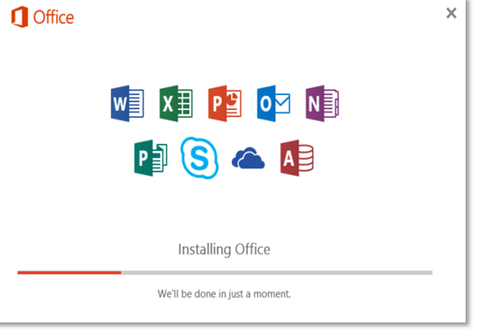

13. You will be prompted with the Microsoft Office License Agreement. View Agreement and click Accept
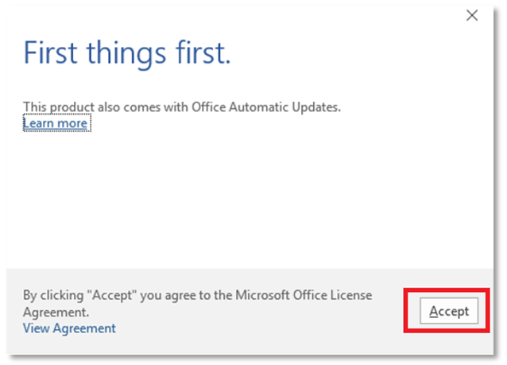.

14. After Office 365 finishes installing, a message will appear to inform it has completed. Click ‘Close’.
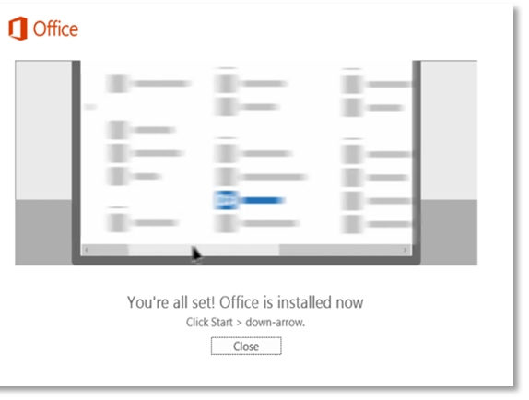

After you click close, we recommend restarting your computer to ensure all changes have applied successfully.
When you start an Office app that's not activated, you'll be prompted to sign in to Office. Be sure to sign in using your @eq (school account) or @qed (corp account).
Your Microsoft Office 365 software is now ready for you to use. This software is only for personal devices and will remain available as long as you're a Queensland state school staff member, or employed by the department (corp).

